Programs day1 lab

1. WRITE A PYTHON PROGRAM TO LEAP YEAR OR NOT?

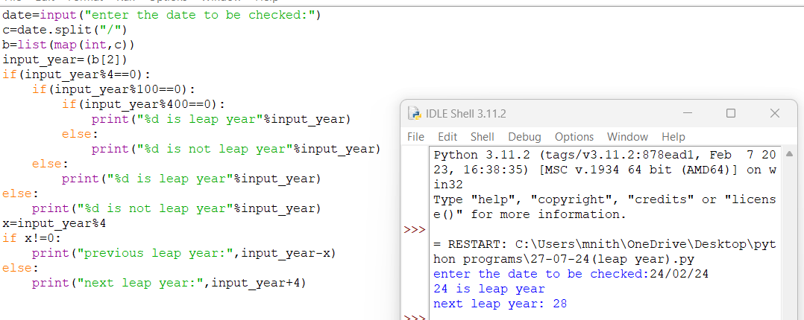

2. WRITE A PYTHON PROGRAM TO PRINT AREA OF THE CIRCLE AND TRIANGLE?

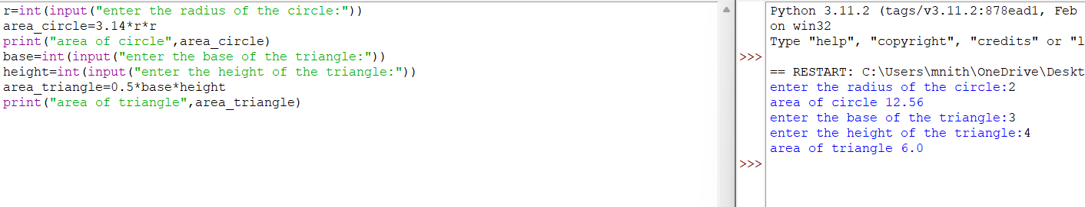

3.WRITE A PYTHON PROGRAM TO PRINT SIMPLE INTREST AND COMPOUND INTREST?

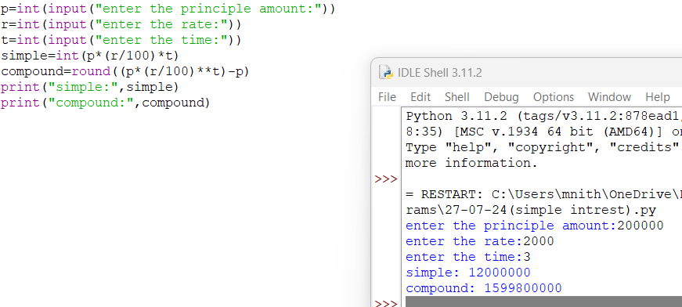

4. WRITE A PYTHON PROGRAM TO CHECK WHETHER THE GIVEN NUMBER IS ODD OR EVEN?

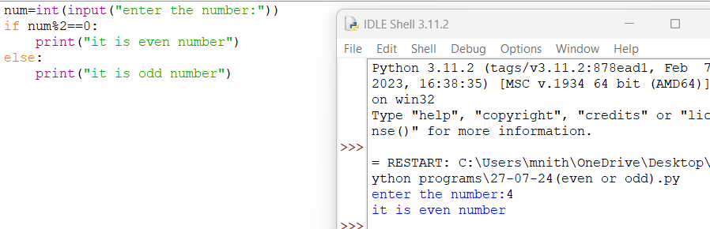

5. WRITE A PYTHON PROGRAM TO CHECK WHETHER THE GIVEN NUMBER IS POSITIVE OR NEGATIVE?

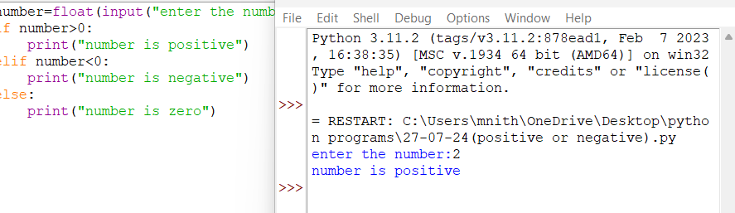

6.WRITE A PYTHON PROGRAM TO CONVERT DECIMAL NUMBER TO BINARY?

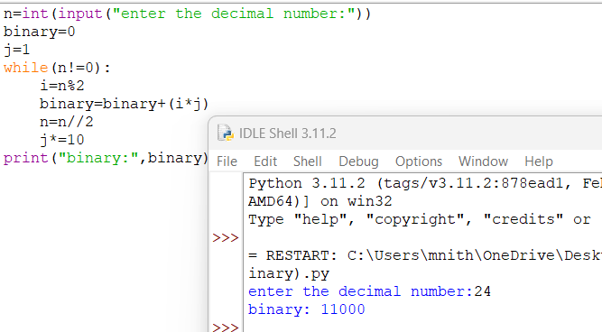

7.WRITE A PYTHON PROGRAM TO PRINT THE GRADE SYSTEM?

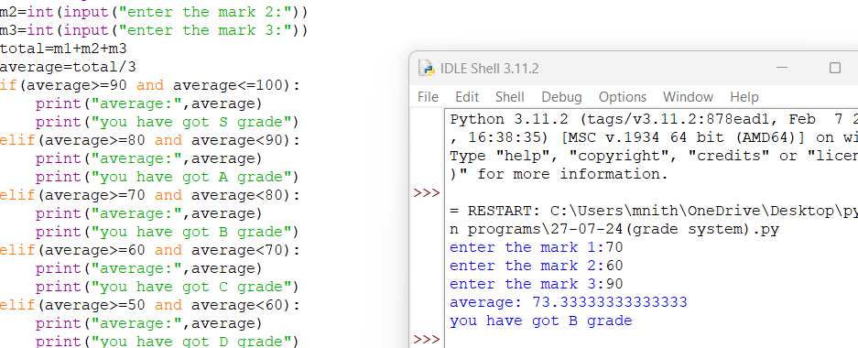

8.WRITE A PYTHON PROGRAM TO FIND ALL PERMUTATION OF GIVEN NUMBER?

